1. Preberi spodnje besedilo, ki je tudi V UČBENIKU NA STRANI 101. V zvezek si napiši naslov Pippi, Tommy and Annika. Zapiši tudi datum naloge. Izpisala sem ti nekaj besed, če pa še katere ne razumeš, pa jo prevedi s pomočjo oranžnega slovarčka ali pa spletnega- klikni na naslednjo povezavo. https://sl.pons.com/prevod/angle%C5%A1%C4%8Dina-sloven%C5%A1%C4%8Dina/fibs
Vocabulary (Besedišče)
exactly-natanko
alone-sam
behave well- obnašati se lepo
tell fibs- povedati drobne laži
bite nails- grizti nohte
fuss- zganjati cirkus, delati kraval, vznemirjati se zaradi nečesa
turn somersaults- delati salte
bake biscuits – peči piškote
ride a bike- voziti kolo
cook sausages- kuhati klobase
toss a ball- metati žogo
climb- plezati
a hollow tree- votlo drevo
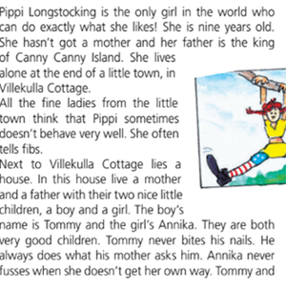
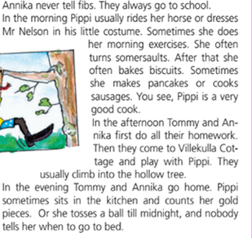
PREPIŠI SI REMEMBER BOX.
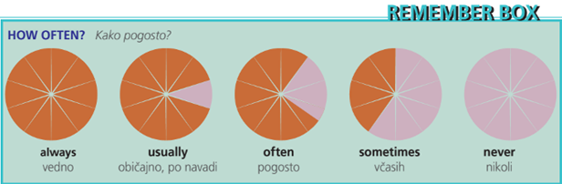
2. Dopolni s pravo besedo. Stavke zapiši v zvezek ali pa si prilepi ta list.
How often does Tommy bite his nails? He NEVER bites his nails.
How often does Annika tell fibs? She ________________________ tells fibs.
How often do Tommy and Annika go to school? They _________________go to school.
How often does Pippi do her morning exercises? She _____________________ does her morning
exercises.
How often does she turn somersaults? She _______________________ turns somersaults.
How often do they climb into the hollow tree? They ______________________________ climb into
the hollow tree.

