Mother's Day
Preberi besedilo in odgovori na dana vprašanja! Pomagaš si lahko s spletnim slovarjem.
https://sl.pons.com/prevod?q=&l=ensl&in=&lf=sl&qnac=
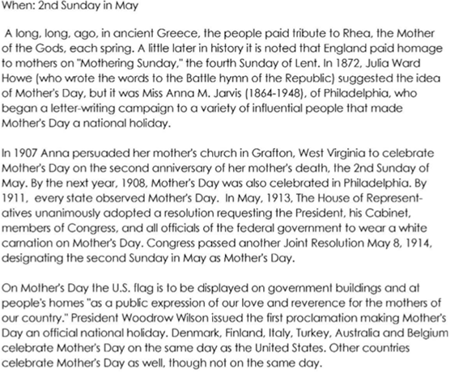
1. What did Anna Jarvis do to help start Mother's Day?__________________________________
2. Name 2 countries that celebrate Mother's Day._______________________________________
3. When do we celebrate Mother's Day in Slovenia?_____________________________________
4. How will you show love to your mother on this special day?_____________________________________________________________________________

