AT THE PIZZA RESTAURANT
1. TRANSLATE. Prevedi letak o piceriji TOPOLINO.
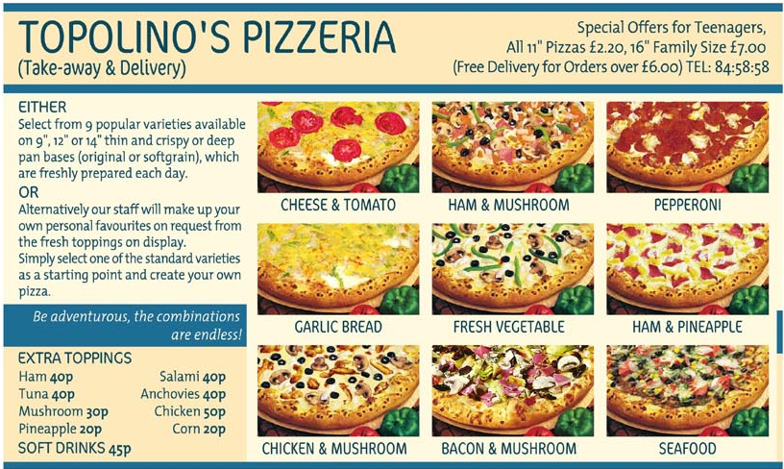

2. PREVERI SI REŠITVE NALOGE 3 IZ UČBENIKA, STRAN 154.
a) Where are Daniel and Megan?
b) How does Megan like the place?
c) How many different pizzas are there?
d) Does Megan know the place?
e) Has Megan been there before?
f) Has Daniel been there before?
g) When was he there?
h) What do they order?
i) Has Megan already seen the film?
j) When did she see it?

3. REŠUJ NALOGE V DELOVNEM ZVEZKU na straneh 119/120, in sicer 39. a, 39. b, 40, 41, 42. a in 42. b. Svoje delo fotografiraj in mi pošlji do večera na mail. V naslednjem tednu pričnemo s preverjanjem.

