REVISION – UNIT 5
1. Preberi, kaj so otroci naročili in v vsak okvirček vpiši pravo ime otroka.
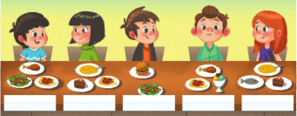
JANE has got soup, a fish and a cake.
ALEX has got chicken, pasta and salad.
BOB has got a hamburger and salad.
SUZY has got soup, pasta and a cake.
MARC has got chicken, pasta and ice cream.

2. K vsakemu slovenskemu poimenovanju prepiši ustreznega angleškega.
SOLATA |  | Izbiraj med:  SALAD, PEAS, ICE CREAM,  A FISH, SOUP, A PEAR,  A STEAK, CHEESE, RICE,  CHICKEN
GRAH
SLADOLED
RIBA
JUHA
HRUŠKA
ZREZEK
SIR
RIŽ
PIŠČANEC

3. K vsakemu angleškemu poimenovanju pripiši ustreznega slovenskega.
A PEAR
A CARROT
PASTA
JUICE
A HAMBURGER
CHEESE
PEAS
APPLES

4. Poimenovanja sadja (FRUIT) in zelenjave (VEGETABLES) ustrezno prepiši v razpredelnico.
LEMONS, CARROTS, PEARS, APPLES, ORANGES, PEAS, TOMATOES, BANANAS, ONIONS

FRUIT | VEGETABLES

5. Zapiši poimenovanja števil.

