**UČNI LIST**

Oglej si skico, ki ponazarja žival na kopnem, in odgovorina vprašanja.

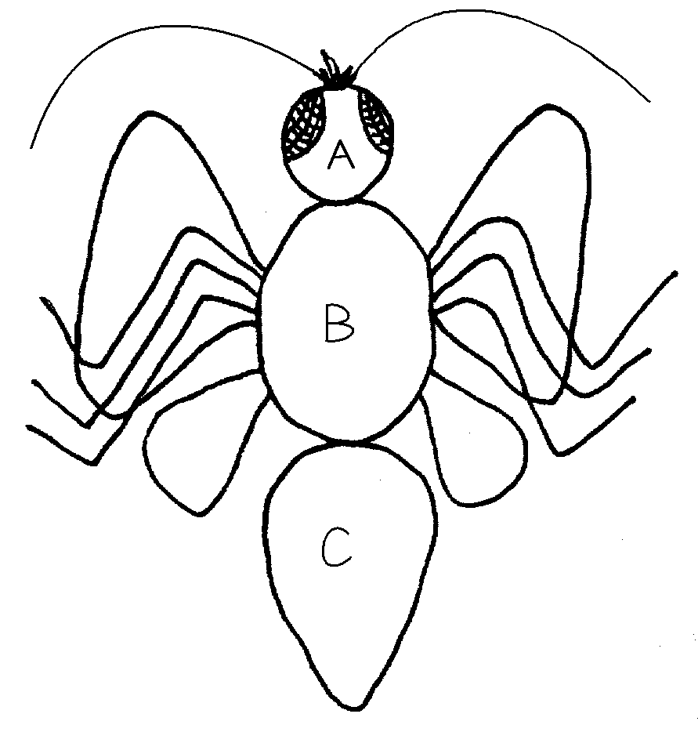

a) Katera skupina živali ima narisano zgradbo? ___________________________

b) Kateri telesni deli živali so označeni s črkami?

|  |  |  |
| --- | --- | --- |
| A _________________ | B ___________________ | C _________________ |

c) Kateri organi so značilni na glavi?

|  |  |  |
| --- | --- | --- |
| 1 __________________ | 2 ___________________ | 3 __________________ |

č) Kateri organi so na oprsju?

|  |  |
| --- | --- |
| 1 _________________ | 2 ____________________ |

d) Poimenuj dve živali, ki imata takšno zgradbo.

|  |  |
| --- | --- |
| 1 _________________ | 2 ____________________ |

e) S čim dihajo živali, ki si jih naštel-a? ________________________________________________.