OLD MACDONALD HAD A FARM_dance, songs, colouring

1. ZA ZAČETEK POSLUŠAJ PESMICO IN ZAPLEŠI – OPONAŠAJ OMENJENE ŽIVALI. PESEM NAJDEŠ NA SPODNJI POVEZAVI:
Farm Animal Song & Dance🎵 Brain Break Activity🎵”Come On Down to the Barnyard Dance”🎵Sing Play Create - YouTube

2. SE SPOMNIŠ PESMICE O STAREM GOSPODU, KI JE IMEL RAZLIČNE ŽIVALI NA KMETIJI?
PRISLUHNI JI ŠE ENKRAT. NAJDEŠ JO NA SPODNJI POVEZAVI. ZAPOJ.
Old MacDonald Had a Farm | Animal Sounds Song | Nursery Rhymes and Baby Songs from Dave and Ava - YouTube

3. ZDAJ PA ZAPLEŠI (DANCE) IN ZMRZNI (FREEZE) OB SPODNJEM POSNETKU.
Old MacDonald Had A Farm Dance | Farm Animal Freeze Dance [Nursery Rhymes + Kids Songs + Baby Songs] - YouTube

4. POSLUŠAJ SPODNJI POSNETEK IN PONOVI POIMENOVANJA ŽIVALI.
Farm Animals Names and Sounds for Kids to Learn | Learning Farm Animal Names and Sounds for Children - YouTube

5. IN ŠE ENA PESMICA O ŽIVALIH NA KMETIJI – TOKRAT TE NA KMETIJO POPELJE LISICA. PRISLUHNI JI NA SPODNJI POVEZAVI.
Old MacDonald Had a Farm + Wheels on the Bus Nursery Rhymes & Kids Songs | Fox and Chicken Cartoons - YouTube
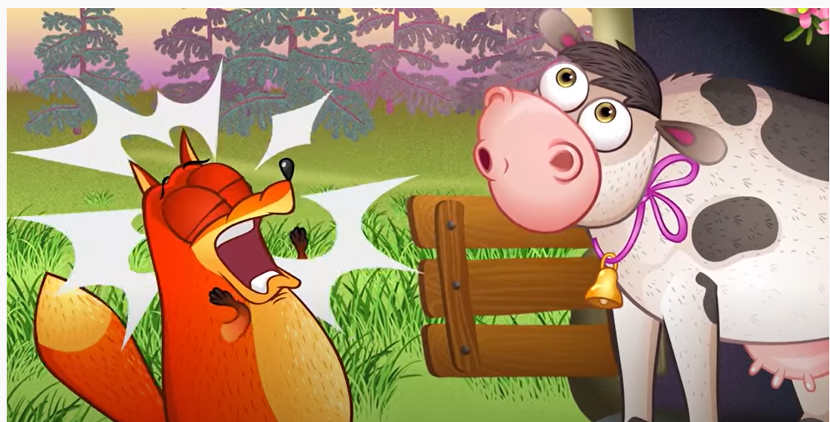

6. IN ŠE POBARVANKA – POBARVAJ JO IN POIMENUJ NARISANE ŽIVALI.

