|  |  |  |
| --- | --- | --- |
| http://img1.etsystatic.com/018/0/6992827/il_570xN.478230515_pb3s.jpghttp://img1.etsystatic.com/018/0/6992827/il_570xN.478230515_pb3s.jpghttp://img1.etsystatic.com/018/0/6992827/il_570xN.478230515_pb3s.jpghttp://img1.etsystatic.com/018/0/6992827/il_570xN.478230515_pb3s.jpghttp://img1.etsystatic.com/018/0/6992827/il_570xN.478230515_pb3s.jpg |  | http://www.clipartsfree.net/vector/large/tux_Vector_Clipart.png  1 |
| 5 – 2 = |
|  |  |  |
| http://img1.etsystatic.com/018/0/6992827/il_570xN.478230515_pb3s.jpghttp://img1.etsystatic.com/018/0/6992827/il_570xN.478230515_pb3s.jpghttp://img1.etsystatic.com/018/0/6992827/il_570xN.478230515_pb3s.jpghttp://img1.etsystatic.com/018/0/6992827/il_570xN.478230515_pb3s.jpg |  | http://www.clipartsfree.net/vector/large/tux_Vector_Clipart.png  3 |
| 4 – 3 = |
|  |  |  |
| http://img1.etsystatic.com/018/0/6992827/il_570xN.478230515_pb3s.jpghttp://img1.etsystatic.com/018/0/6992827/il_570xN.478230515_pb3s.jpghttp://img1.etsystatic.com/018/0/6992827/il_570xN.478230515_pb3s.jpg |  | http://www.clipartsfree.net/vector/large/tux_Vector_Clipart.png  4 |
| 3 – 1 = |
|  |  |  |
| http://img1.etsystatic.com/018/0/6992827/il_570xN.478230515_pb3s.jpghttp://img1.etsystatic.com/018/0/6992827/il_570xN.478230515_pb3s.jpghttp://img1.etsystatic.com/018/0/6992827/il_570xN.478230515_pb3s.jpghttp://img1.etsystatic.com/018/0/6992827/il_570xN.478230515_pb3s.jpghttp://img1.etsystatic.com/018/0/6992827/il_570xN.478230515_pb3s.jpg |  | http://www.clipartsfree.net/vector/large/tux_Vector_Clipart.png  1 |
| 5 – 1 = |
|  |  |  |
| http://img1.etsystatic.com/018/0/6992827/il_570xN.478230515_pb3s.jpghttp://img1.etsystatic.com/018/0/6992827/il_570xN.478230515_pb3s.jpg |  | http://www.clipartsfree.net/vector/large/tux_Vector_Clipart.png  2 |
| 2 – 1 = 1 |

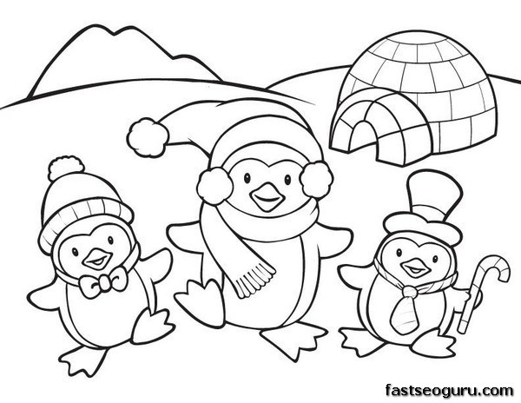

4

2

3

5

★

3

3

2

2

2

2

1

4

5

★

4

4

★

★

★

1

4

3

★

★

1

★

★

1

1

2

1

1

1

1

5

|  |  |  |  |  |
| --- | --- | --- | --- | --- |
| 5 | - | 4 | = |  |
|  |  |  |  |  |
| 4 | - | 2 | = |  |
|  |  |  |  |  |
| 5 | - | 2 | = |  |
|  |  |  |  |  |
| 5 | - | 1 | = |  |
|  |  |  |  |  |
|  |  | ★ |  | 5 |